Module 1:
ARCHITECTURE OF MSP430
Embedded Systems – Introduction
Definition of Embedded Systems
An Embedded System refers to a computer designed to perform specific tasks or functions within a larger system. Unlike general-purpose computers, which can execute a wide variety of tasks, an embedded system is focused on a particular application or function. These systems typically consist of hardware and software components tailored to meet particular performance criteria, such as speed, power consumption, or size.
Embedded systems are used in a wide range of industries, including automotive, consumer electronics, telecommunications, industrial automation, and healthcare.
Characteristics of Embedded Systems
Dedicated Functionality: Embedded systems are designed to perform a specific task or set of tasks. For example, a washing machine controller or a microwave oven’s control system.
Real-time Operation: Many embedded systems must work in real-time, meaning they must respond to inputs or events within strict timing constraints. For instance, an airbag control system in a car must deploy within milliseconds after detecting a collision.
Resource Constraints: These systems often have limited computational resources, such as processing power, memory, and storage. Therefore, embedded systems must be highly efficient in their use of resources.
Reliability and Stability: Embedded systems are designed to operate continuously without failures, as they are often used in safety-critical applications like medical devices or industrial machines.
Interfacing with External Devices: Embedded systems often interact with sensors, actuators, displays, and other peripherals to achieve their task.
Components of Embedded Systems
An embedded system consists of several key components:
Hardware: This includes the microcontroller or microprocessor, memory, input/output devices, sensors, and actuators. The hardware is responsible for executing the system’s functions.
Microcontroller/Processor: The heart of an embedded system, it executes instructions and controls other components. It can be an 8-bit, 16-bit, 32-bit, or even a 64-bit processor depending on the application.
Memory: Embedded systems typically use ROM (Read-Only Memory) for storing the firmware or software, and RAM (Random Access Memory) for temporary data storage during operation.
Input/Output Devices: These include peripherals like buttons, displays, touchscreens, motors, etc., that allow the system to interact with the external environment.
Software: This is the code that defines the system's behavior. The software is generally stored in the embedded system's memory (typically ROM or Flash memory) and interacts with the hardware to accomplish the specific task.
Firmware: The embedded software that runs on the system, often low-level code responsible for interacting directly with hardware.
Operating System (Optional): Some embedded systems run a simple operating system, while others operate without one (bare-metal systems). When used, these are often Real-Time Operating Systems (RTOS) designed to handle time-sensitive tasks efficiently.
Types of Embedded Systems
Standalone Embedded Systems:
These systems operate independently and do not require a host system. An example would be a microwave oven or a digital camera.
Real-Time Embedded Systems:
Real-time embedded systems must respond to inputs or events within a specific time frame. These are used in applications like industrial automation, robotics, and aerospace.
Networked Embedded Systems:
These systems are designed to communicate with other systems over a network. Examples include IoT devices (e.g., smart thermostats, security cameras) and networked appliances.
Mobile Embedded Systems:
These are portable systems designed for specific mobile applications. Smartphones and wearable devices, such as smartwatches, are examples of mobile embedded systems.
Applications of Embedded Systems
Embedded systems have widespread applications across various industries:
Automotive: Embedded systems are used in vehicles for functions like engine control, anti-lock braking systems (ABS), airbags, and infotainment systems.
Consumer Electronics: Common examples include smart TVs, microwave ovens, digital cameras, and home appliances.
Healthcare: Embedded systems in medical devices such as pacemakers, insulin pumps, and diagnostic equipment.
Industrial Automation: Embedded systems control machinery, robotics, and automation equipment in factories and production lines.
Telecommunications: Embedded systems power devices like routers, base stations, and communication infrastructure.
Aerospace and Defense: Embedded systems are used in avionics, satellite systems, military systems, and drones.
Advantages of Embedded Systems
Efficiency: Embedded systems are highly optimized to perform specific tasks with minimal resource consumption (CPU power, memory, etc.).
Cost-Effective: As they perform specific functions, the hardware required can be made simpler and more cost-effective compared to general-purpose computers.
Compact Design: Embedded systems are often designed to be compact, with minimal physical size, making them suitable for embedded applications in limited spaces.
Low Power Consumption: These systems are often designed to operate with minimal energy consumption, which is essential for battery-powered devices like wearables.
Challenges in Embedded System Design
Resource Constraints: Memory, processing power, and storage are limited, so designers must optimize software and hardware to work within these constraints.
Real-time Performance: Meeting real-time constraints for systems that require timely responses (such as automotive or medical systems) is challenging.
Reliability: Embedded systems are often used in critical applications, meaning they must be designed for maximum reliability and fault tolerance.
Security: As embedded systems are increasingly connected to networks (IoT), ensuring the security of the system from cyber-attacks is a growing concern.
MSP430 - Anatomy of microcontroller
The anatomy of an MSP430 microcontroller includes several key components that enable it to perform specific tasks. These include:
- Central Processing Unit (CPU): Executes instructions.
- Memory: Stores data and instructions.
- Input/Output (I/O) Pins: Facilitate communication between the microcontroller and external devices.
- Clock Generator: Provides timing and synchronization for the microcontroller.
- Interrupt Controller: Manages interrupt requests for handling time-sensitive events.
Memory
The MSP430 microcontroller features a simple and efficient memory architecture. Its memory is organized into two primary segments:
- Flash Memory (Program Memory): Stores the program code (firmware). Flash memory is non-volatile, meaning it retains data even when power is turned off.
- RAM (Random Access Memory): Temporarily holds data and variables during program execution. RAM is volatile and loses its contents when power is removed.
The MSP430 typically has separate memory for the program code and data, known as the Harvard Architecture.
Additionally, the memory map is memory-mapped, which means the microcontroller treats both memory and I/O registers as addresses that can be read or written to in the same way.
Software
The software running on the MSP430 microcontroller controls its behavior and operation. The software includes:
- Firmware: The low-level software that runs on the microcontroller and directly interacts with hardware. This includes device drivers, initialization routines, and application code.
- Compilers: The code written in higher-level languages such as C is compiled into machine code that the MSP430 CPU can execute. Texas Instruments provides an integrated development environment (IDE), Code Composer Studio, to program and debug MSP430-based systems.
- Libraries and Functions: MSP430 provides libraries for common tasks like I/O operations, interrupt handling, and communication protocols (e.g., UART, SPI, I2C).
Pin out (MSP430G2553)
The MSP430G2553 is one of the most popular devices in the MSP430 family. Its pinout consists of multiple pins that serve various functions, including:
- Vcc: Supply voltage pin.
- GND: Ground pin.
- Digital I/O Pins: Pins that can be configured as input or output for communication with external devices.
- Analog Input Pins: Used for connecting sensors or analog devices to the microcontroller.
- Reset Pin: Resets the microcontroller when triggered.
- Clock Pins: Pins used for the external clock input and output.
- JTAG/SBW (Serial Wire Debug): Used for debugging the microcontroller during development.
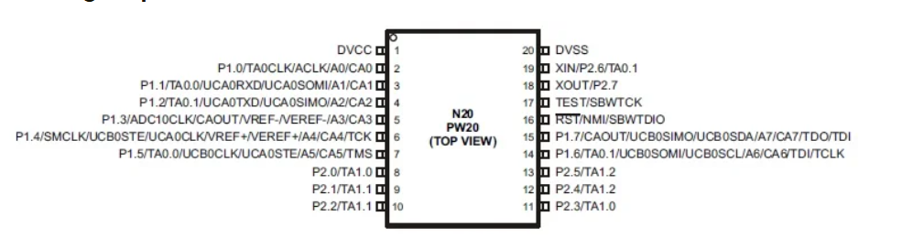
The MSP430G2553 has a total of 20 pins, allowing flexibility for interfacing with a wide range of external components.

Functional Block diagram
The functional block diagram of the MSP430 microcontroller highlights the main components of the system and their interconnections:
- CPU: The core processing unit that executes instructions.
- Memory: Flash memory and RAM for data and program storage.
- Peripherals: Includes timers, ADCs, communication interfaces like UART, SPI, and I2C.
- Clock System: Generates clock signals for the CPU and peripherals.
- Interrupt Controller: Manages interrupt requests from peripherals and external sources.
- Power Management: MSP430 features low-power modes that allow the device to operate with minimal energy consumption.
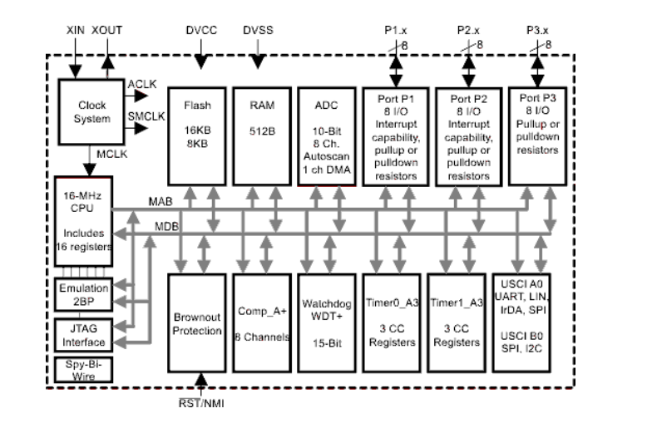
The diagram shows how the CPU, memory, peripherals, and other components work together to perform embedded system tasks efficiently.

Memory
CPU
The CPU of the MSP430 microcontroller is a 16-bit RISC processor, meaning it uses a reduced instruction set computing architecture for efficient execution of instructions. Key features of the MSP430 CPU include:
- Registers: A set of general-purpose registers and special function registers for data manipulation and program control.
- ALU (Arithmetic Logic Unit): Performs arithmetic and logical operations.
- Control Unit: Decodes instructions and coordinates the execution of various CPU components.
The MSP430 CPU is designed to be simple yet powerful, with features optimized for low-power operation and quick task execution.

Memory mapped input and output
In MSP430, both memory and I/O devices are mapped into the same address space. This is known as memory-mapped I/O. The key benefits of this approach include:
- Simplified Addressing: Memory and I/O registers can be accessed using the same addressing scheme, making programming easier.
- Efficient I/O Access: I/O registers (such as for timers, ADCs, and communication peripherals) are treated as memory addresses, allowing for efficient read/write operations.
- Direct Access: Access to peripherals is done through simple memory access instructions, which is often faster than using specialized I/O commands.

Clock generator
The Clock Generator in the MSP430 microcontroller provides the timing signals that synchronize the operation of the CPU and peripherals. The clock system can be configured to select from several sources:
- Internal Oscillator: A low-power, built-in clock source that can operate without external components.
- External Oscillator: An external crystal or resonator can be connected for higher precision and stability.

Exceptions- Interrupts and Resets.
MSP430 provides robust handling of exceptions, which include interrupts and resets. These are mechanisms that allow the microcontroller to respond to external or internal events:
- Interrupts: Interrupts are signals that temporarily halt the normal execution of the program to attend to high-priority tasks. Interrupts can be triggered by peripherals (like timers, ADCs, or communication interfaces) or external devices.
  - The MSP430 has a nested interrupt system, meaning higher-priority interrupts can preempt lower-priority ones.
  - Interrupt vectors are used to point to the appropriate code that handles specific interrupt events.
- Resets: A reset occurs when the microcontroller is initialized after power-up or a manual reset event. During a reset, the system is returned to a known state, and the program execution begins from the starting point.
  - The reset pin or power-up event triggers the reset process, clearing registers and initializing the system.

